Log into: www.isbe.net/ELIS .
Click on “Educator Access”
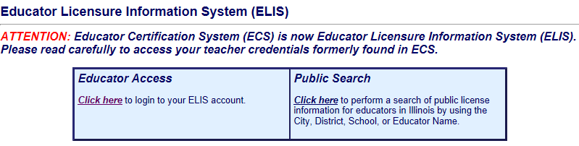

Click on “Sign Up Now” in the left hand column
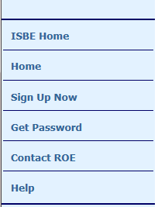
Complete the questions on the IWAS for Educators Account page
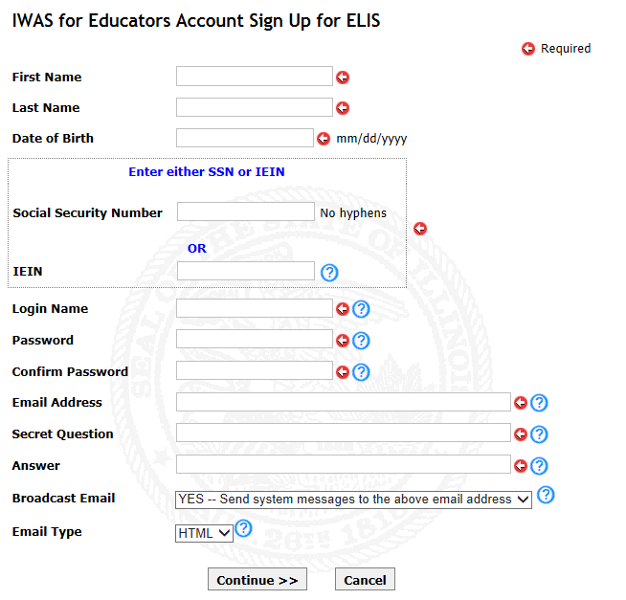

When completed you’ll be directed to your ELIS account Home Page

Select the license type you’re applying for.
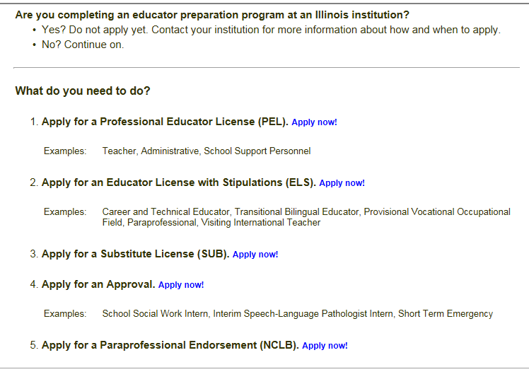
Click NEXT when done reading.
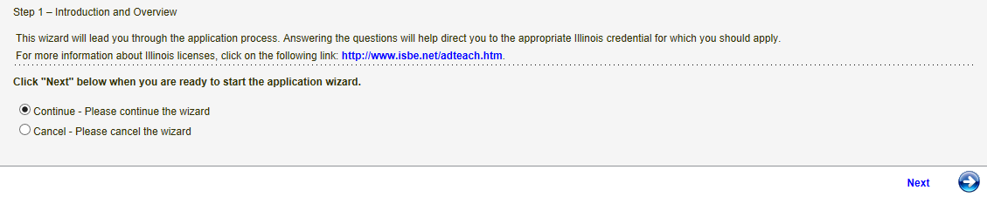

The system will then walk you through a series of questions, please read theses carefully.

You’ll be directed to enter a credit or debit card for payment at the end of the application process.

